|  |  |
| --- | --- |
| USAID Logo | USAID GLOBAL HEALTH SUPPLY CHAIN PROGRAM  Procurement and Supply Management |

|  |
| --- |
| Inventory Turnover Analysis  **User Guide**  August 2024 |

The USAID Global Health Supply Chain Program-Procurement and Supply Management (GHSC-PSM) project is funded under USAID Contract No. AID-OAA-I-15-0004. GHSC-PSM connects technical solutions and proven commercial processes to promote efficient and cost-effective health supply chains worldwide. Our goal is to ensure uninterrupted supplies of health commodities to save lives and create a healthier future for all. The project purchases and delivers health commodities, offers comprehensive technical assistance to strengthen national supply chain systems, and provides global supply chain leadership.

GHSC-PSM is implemented by Chemonics International, in collaboration with Arbola Inc., Axios International Inc., IDA Foundation, IBM, IntraHealth International, Kuehne + Nagel Inc., McKinsey & Company, Panagora Group, Population Services International, SGS Nederland B.V., and University Research Co., LLC. To learn more, visit [ghsupplychain.org](http://www.ghsupplychain.org/)

DISCLAIMER:  
The views expressed in this publication do not necessarily reflect the views of the U.S. Agency for International Development or the U.S. government.

**Contents**

Step 1: User System Setup 4

Step2: Running the Tool 5

Step 3: Open the Final Report………………………………………………………………………………………………………………….9

Step 4: Analyzing the Final Report……………………………………………………………………………………………………………9

National Summary Page……………………………………………………………………………………………………………10

Facility Analysis Page……………………………………………………………………………………………………………….12

**Inventory Turnover Analysis User Guide**

# **Note:**

* **Step 1** needs to be done only the first time a user downloads the code.
* If python and the packages to run the tool are already installed, skip to Step 2.

## Step 1: User System Setup

### Install Python

Install the latest version of python from this webpage <https://www.python.org/downloads/> that is appropriate for your computer. Go through the installation prompts on your computer as directed.

### Install Python Packages

In the folder that contains the tool you will see a document called **requirements.txt**. This document helps to quickly install all the libraries needed to run this program.

To do this, open the **command prompt** on your PC and navigate to the to3-inventory-analysis folder

1. Copy the path to the folder – Right click on the folder name (highlighted below) and select Copy address.

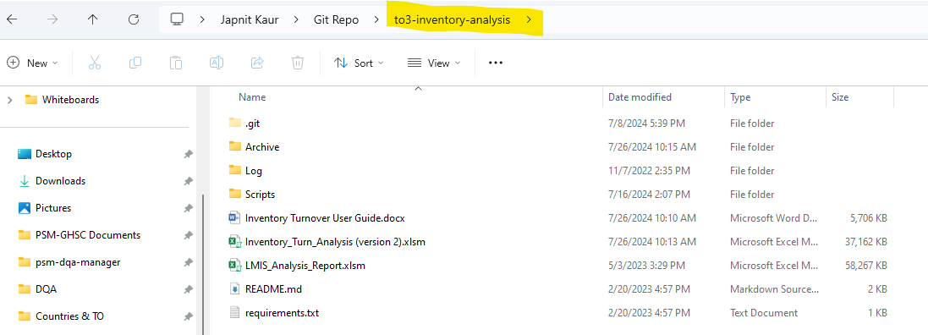

1. To navigate to the program folder in the command prompt enter the following code after the >

cd *paste*/*path/to/the/to3-inventory-analysis/folder*

1. Press Enter. The folder path should now appear before the >

1. Enter the following text into the command prompt:

pip install -r requirements.txt

1. You will see text running in the command prompt, which is installing each package. Once all libraries are installed you should return to showing the line with your current folder followed by >.

Package installation is now complete

## Step 2: Running the tool

Follow the steps below to run the tool

1. Once the setup is done, navigate to the “Scripts” folder by typing the command *cd Scripts* in the command prompt

1. Next run the tool with the following command: *python inventory_analysis_gui.py*

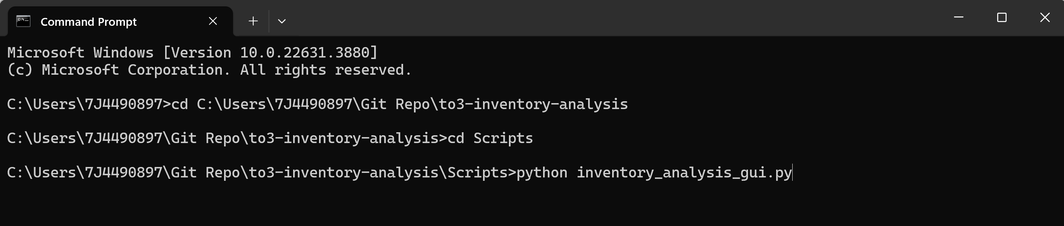

1. Press Enter and a graphical user interface will pop up with a prompt to browse a file.

1. Click the Browse Files button to navigate to a stock file that contains consumption and stock on hand fields. This file usually comes out of an eLMIS system and needs to be either an excel or a csv file. The opened file name will be displayed at the top in blue.

1. Next select values from the drop downs for each field.

* **Min Value**: Select a min months of stock value according to the country’s policies
* **Max Value**: Select a max months of stock value according to the country's policies
* **Delivery Frequency**: Select one from Monthly, bimonthly or Quarterly Delivery frequency according to country’s policies

Note: The min, max and delivery frequency fields help calculate an ideal Inventory Turn range (called Planned IT in the final dashboard), where all products in a facility are expected to fall.

* **Data Type**: Select transactional if the selected input file contains multiple entries for a single month. If the stock data contains one entry per month for a facility/product combination, select cumulative.
* **Product**: Select the field name that corresponds to product names column in the input file
* **Facility**: Select the field name that corresponds to facility name column in the input file
* **Region**: Select the filed name that corresponds to either State, District or Province or any field that helps narrow down on one facility.
* **Date Field**:Select the field name that corresponds to date column in the input file
* **Consumption Field**: Select the field name that corresponds to consumption data column in the input file
* **Stock on Hand Field**: Select the field name that corresponds to stock on hand data column in the input file
* **Time Window for Rates**: Select an integer value for calculations over a rolling window. By default, 12 is selected for a rolling window of one year.

Once all selections are made, click “Run Analysis” Button.

## Step 3: Open the Final Report

Once the tool is done running, click the “open report in excel” button to open the final dashboard.

## Step 4: Analyzing the Final Report

Once the final report opens, click the “Enable Content” button in the yellow warning ribbon. This will enable all the macros.

Next navigate to Data option on the ribbon at the top and click “Refresh all” to refresh the tool and pull the output files from the most recent run.

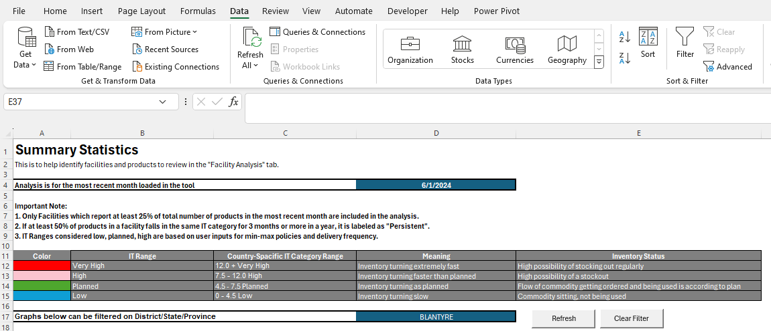

#### National Summary Page

User can now analyze the “National Summary” tab for the most recent month in the input stock file. The aim is to identify facilities in the very high, high or low IT range category on this page and do an in-depth analysis on the next page for each of these identified facilities.

The page displays the month of analysis at the top followed by a description of each Inventory turn category along with the color it used for each category in the charts below.

The country specific IT Category Range is calculated based on the min, max and delivery frequency provided by the user when running the tool. The colors against each category denote the color used in the charts below for each. User can use the region (District/state/province) filter (highlighted in a blue box) to filter for one particular value.

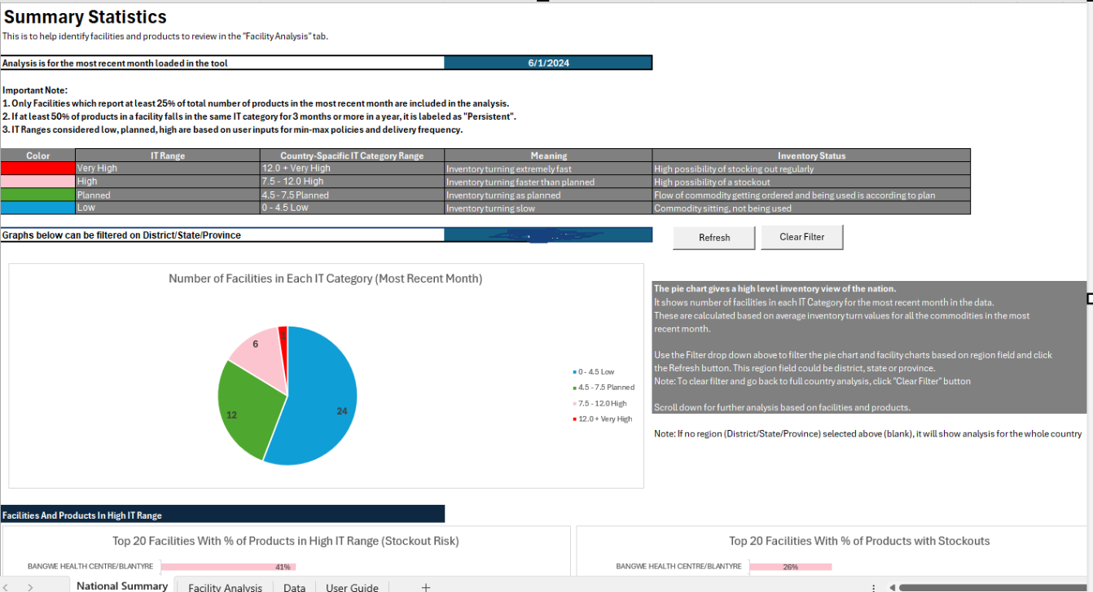

To filter on region:

* Select a value from the drop down and click “Refresh” button
* Use “Clear Filter” button to go back to country-wide analysis

Scroll down to narrow down on facilities not falling in the planned IT Range with the help of bar charts.

#### Facility Analysis Page

##### Step 1

Once the user has identified facilities from the National Summary page they can do further analysis on the Facility Analysis page. On this page the user can find a facility by first selecting a region and then selecting the facility from a filtered drop-down list.

They can then see number of products in the selected facility falling in the different IT Ranges over a year through stacked column charts.

Next the user can filter for one month in a year and see a list of products with their IT category in a bar chart. This helps user pick problematic products to analyze in the next step.

##### Step 2

In the next step on the “Facility Analysis” page, user can select a product from the drop down list and through IT, Consumption and MOS charts over a year, can visualize a potential cause for this product not following a planned IT trend. The descriptions in grey boxes on the side help the user interpret these charts.



